1. **PROJECT TITLE : SOCIAL DISTANCING ALERTING SYSTEM**
2. **INTRODUCTION**
   1. **Overview**

Created a system that uses recorded videos to analyze images from public areas like shopping malls, streets to see whether the public is adhering to safety measures, like maintaining social distancing.

This project uses python combined with deep learning and computer vision to monitor social distancing. A web application is built and is hosted on the cloud which streams the video of  Social distancing Violations

* 1. **Purpose**

COVID-19 can live for hours or days on a surface, depending on factors such as sunlight, humidity, and the type of surface. It may be possible that a person can get COVID-19 by touching a surface or object that has the virus on it and then touching their own mouth, nose, or eyes. However, this is not thought to be the main way the virus spreads. Social distancing helps limit opportunities to come in contact with contaminated surfaces and infected people outside the home.So,this project helps in detecting the people who violate social distancing.

1. **RESULT**

**3.1 Screenshots of output**

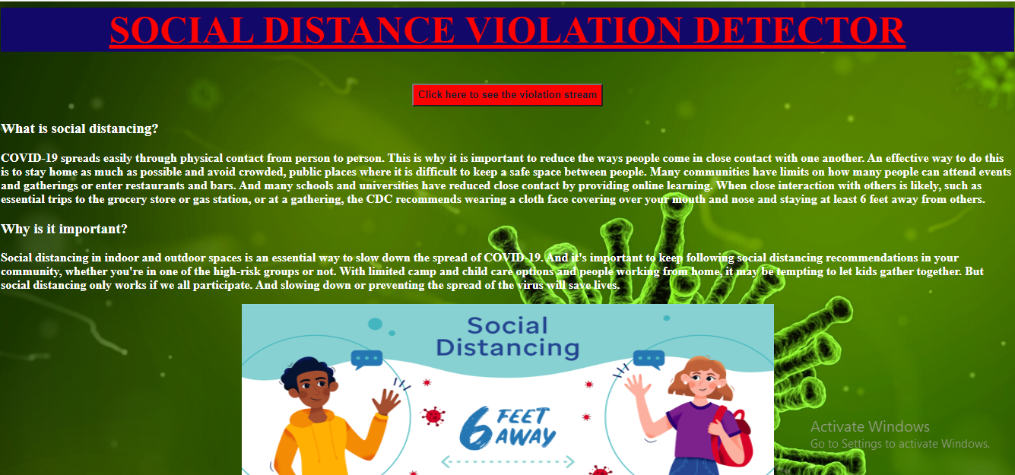

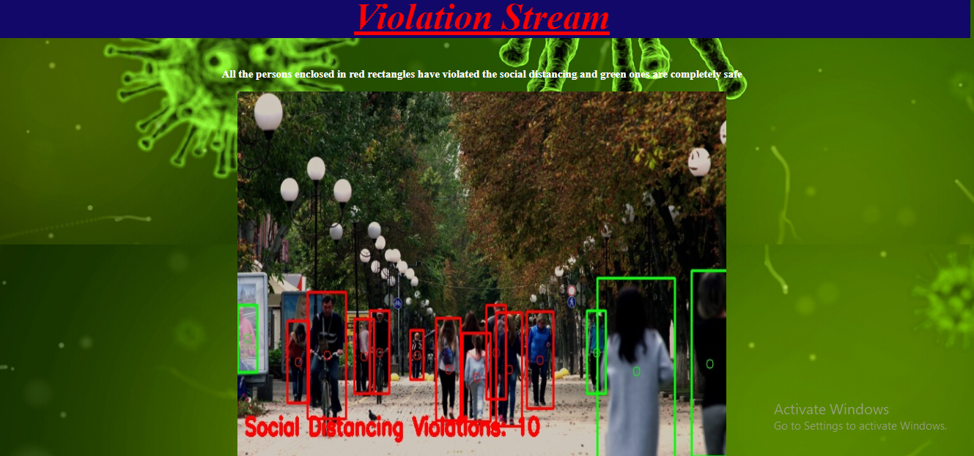

1. **APPLICATIONS**

This AI application can be utilized in numerous spots like airports, schools, emergency clinics, shopping centers with the goal that any infringement of social distancing can be effectively recognized.

Additionally, the world is under finished shutdown during this COVID-19 yet on the off chance that there is innovation like SOCIAL DISTANCING ALERTING SYSTEM, at that point, it could be conceivable to resume everything which can then recently guarantees social distancing, a preventive measure for COVID-19.

1. **CONCLUSION**

This program is a very simple and basic implementation of the Social Distancing Detector. This code can serve as a basis for more complex programs which can be developed from this. This has several applications such as the **CCTV cameras** which can be equipped with this software tool to monitor the practice of social distancing in a huge crowd or in an office environment.

1. **FUTURE SCOPE**

The below lines give few ideas how this application be improved :

* Using a faster model in order to perform real-time social distancing analysis.
* Use a model more robust to occlusions.
* Automatic calibration is a very well known problem in Computer vision and could improve a lot the bird eye view transformation on different scenes.
* **The way to improve our social distancing detector is to utilize a proper camera calibration.**
* **Also we can improve the people detection process as** OpenCV’s YOLO implementation is quite slow not because of the model itself but because of the additional post-processing required by the model.To further speedup the pipeline, consider utilizing a Single Shot Detector (SSD) running on your GPU — that will improve frame throughput rate considerably.